Flappy Bernie

The objective of the game is to get the character, Bernie, past as many $100 bills of varying heights as possible through using the space bar to boost him up while gravity naturally makes him fall.

By hosting the theme of a prominent politician, this game sparks discussion about the current global and socioeconomic condition in an non-intimidating and accessible manner.

As the game requires only one motion, it is easy to learn and able to transcend cultural and generational barriers. It allows players to enjoy a quick dose of entertainment without long-term commitments, unlike games such as Plants Vs. Zombies or Candy Crush. This nature also makes it highly addictive as the player repeatedly tries to beat his/her own high score or that of family and friends.

While the premise of the game appears modest, its simplicity makes it an essential game to know how to code and creates universal appeal.

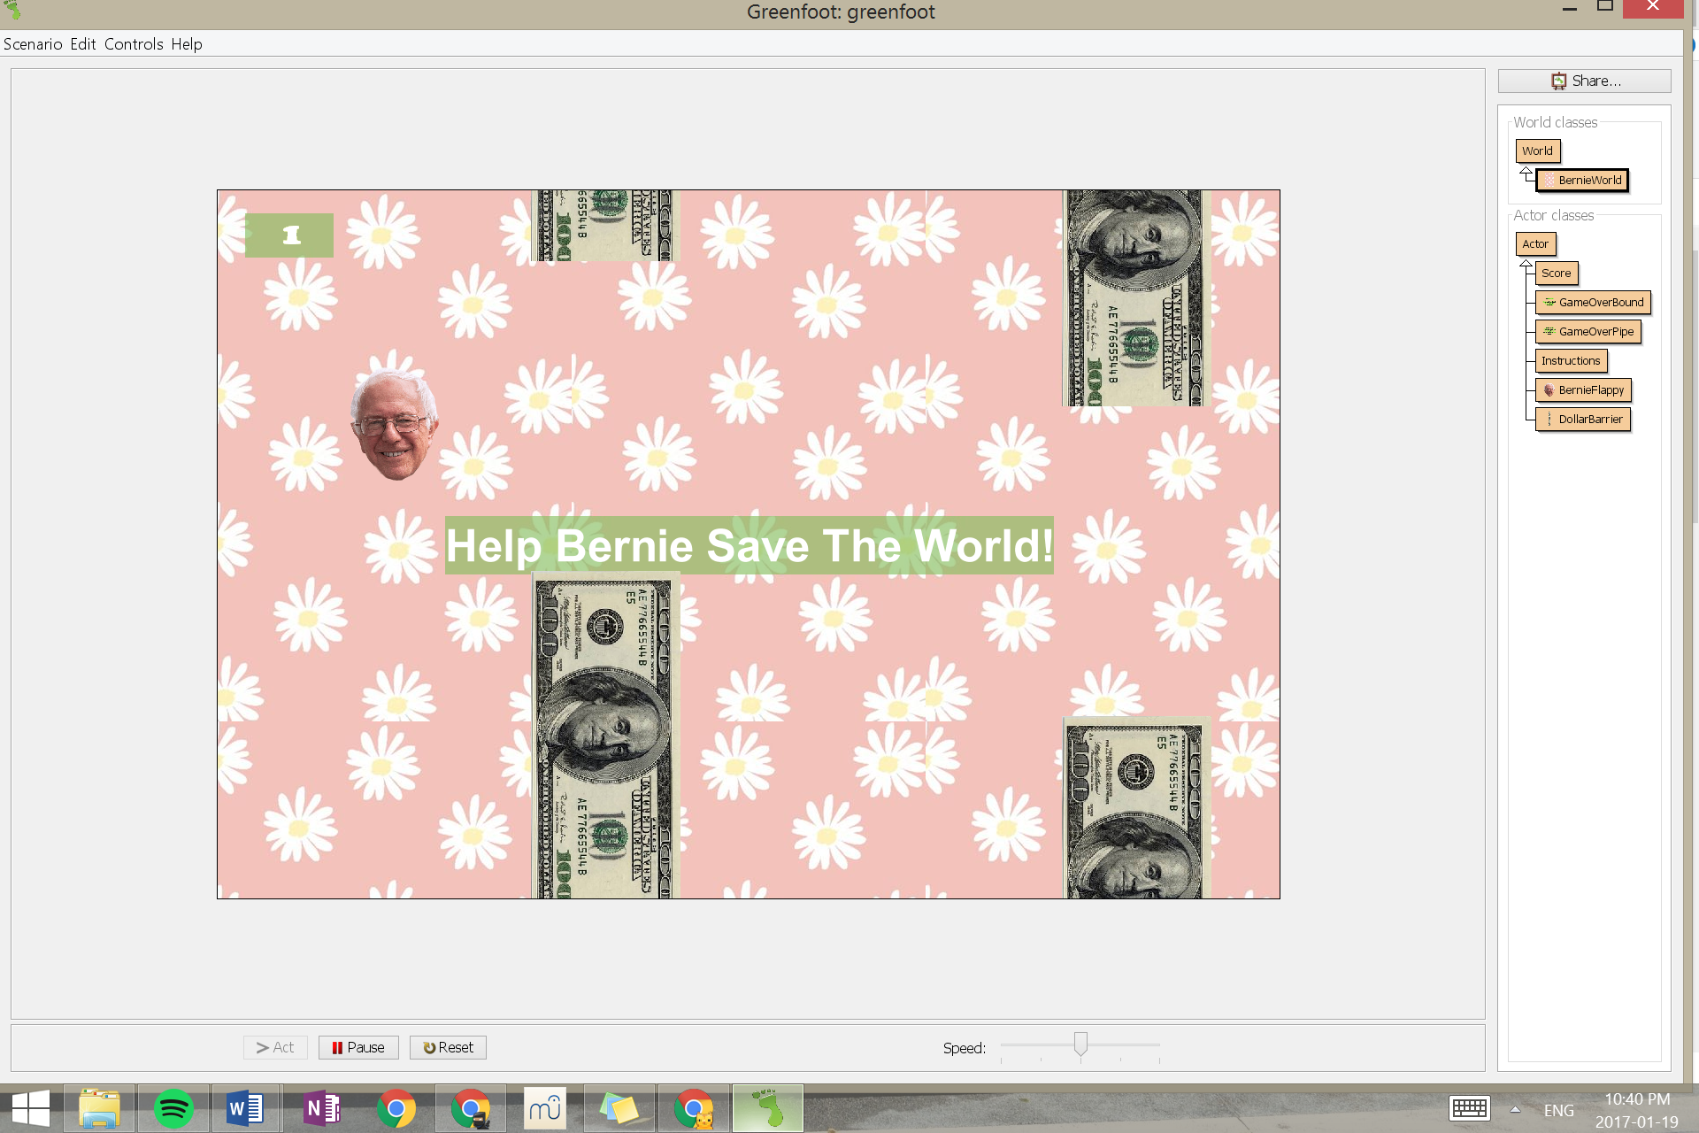

Bottom and top of screen are to be avoided

Bills are to be avoided

Main character

Space between pairs of bills is held constant

Score counter